Christmas Language and Customs
Merry Christmas!
Here’s to a merry Christmas!
To a merry Christmas!
Merry Christmas! Cheers!
Enjoy the Christmas holiday.
Have a nice Christmas season.
Season’s greetings!
Happy holidays!
Yule
Old English (“Ye olde English”)
Yuletide
Xmas
Christmas Eve
(Valentine’s Day, Easter Sunday, Mother’s Day etc.)
On the eve of …
Christmas Carol
Noel
Lingua Franca
Carolling
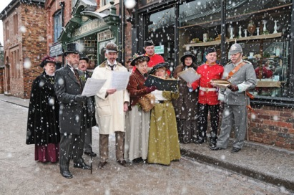
A Christmas Carol by Charles Dickens
Merry Christmas one and all!
Scrooge
He’s a real Scrooge!
Humbug
Bah! Humbug
What an old humbug you are!
Father Christmas
St. Nicholas (Sinterklaas)
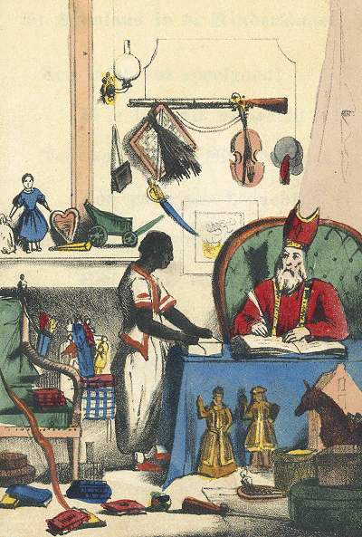
Santa Claus
Urban myth/legend
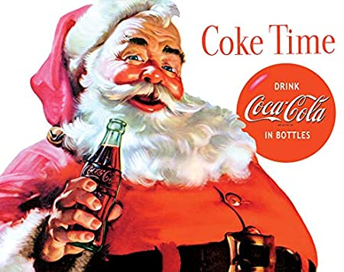
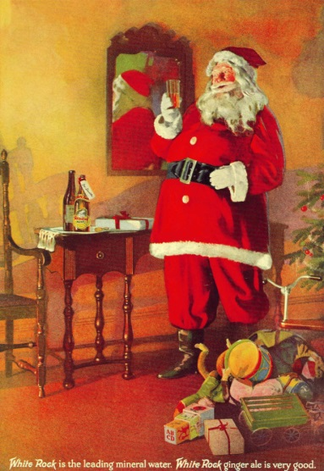
Christmas stocking
Naughty or nice
The naughty list
A lump of coal
Christmas cake
Christmas pudding / Plum pudding
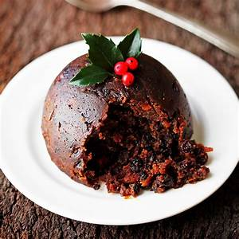
Mince pies
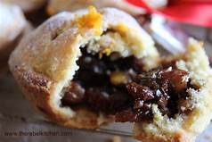
Yule log
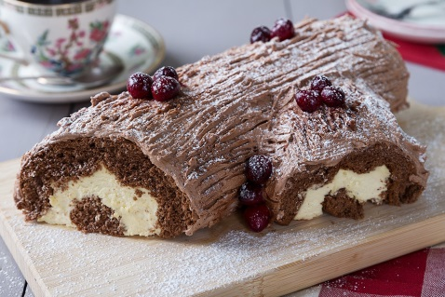
Christmas dinner
Roast meat and pudding
Boar
Pig’s head
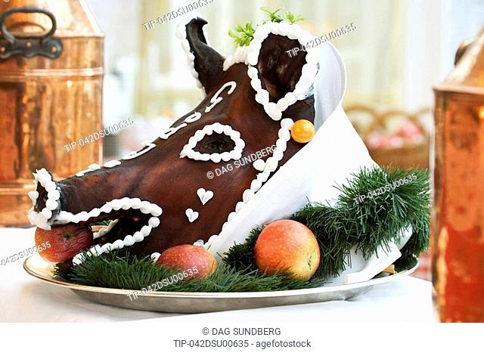
Turkey
Stuffing
Cranberry sauce
Christmas cracker
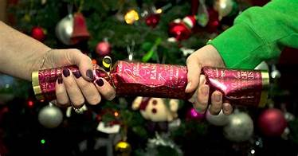
Christmas card
Christmas decorations
Christmas tree
A real (Christmas) tree
An artificial (Christmas) tree
Holly (Christ’s thorn)
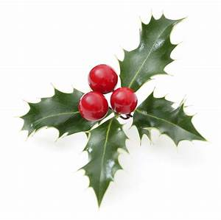
Mistletoe
Fertility symbol
Kissing under the mistletoe
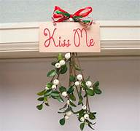
The twelve days of Christmas (December 25th – January 5th)
Feast of the Epiphany (January 6th)
Epiphany Eve (January 5th)
Twelfth Night
Boxing Day
St. Stephen’s Day
Alms box
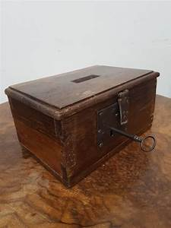
Christmas box
Modern Traditions
Secret Santa
The office Christmas party
Milk and cookies
Sherry and a mince pie
The Queen’s speech
The James Bond movie
Home Alone
Christmas sweater
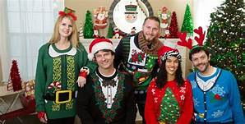
Christmas cracker hat
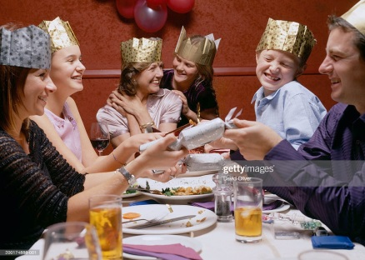

New Year Language and Customs
Janus (God of change and new beginnings)
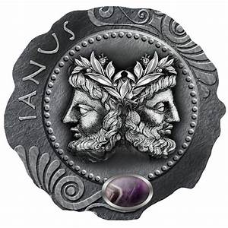
January first/ January the first/the first of January
New Year’s Eve
New Year’s Day
Seeing in the New Year
New Year’s resolution
Resolve
Make a resolution
Break a resolution
The countdown
The bells
Happy New Year!
New Year’s kiss/ handshake
Auld Lang Syne
Should old acquaintance be forgot, and never brought to mind?
Hogmanay
First foot/ first footing
Shortbread/whisky/coal
Mass gatherings
Fireworks display
New Year ball drop (New York)
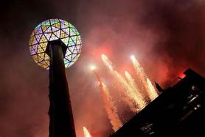
GMT
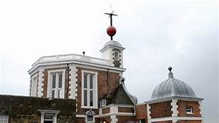

Have a wonderful Christmas and a Happy New Year!

