Japan’s Problem with Noise Pollution
Feel woolly-headed, distracted and overwhelmed, but not sure why? The answer may be in the sound waves of the city.
Despite Japan’s international image as a country of serene temples and quiet gardens, according to a 2018 report by the World Health Organization, Japan is the noisiest country in the world.

To prevent negative effects, the WHO recommends avoiding being exposed to noise over 53 decibels. The legal average limit in Japan is about 70, a number based on data 50 years out of date, according to Prof. Matsui of Hokkaido University who spoke about the problem in an NHK feature on noise pollution in Japan.
While the WHO’s numbers are likely to be a bit skewed due to the vast size of Japan’s major cities and the presence of several noise-creating airbases, there is definitely more than a grain of truth to this decibel-intense soundscape.Even in local news concerns about noise pollution are rising with noise coming in as one of the top reasons citizens complain to the Environment Dispute Coordination Commission, a government organization that oversees environmental disputes.

Noise pollution in Japan’s cities
Of course, in rural areas, there are plenty of pockets of quiet. But in major cities, the combination of a culture of constant intrusive alerts and warnings, salespeople screaming out deals and stores’ background music, thin walls and seasonal (obnoxiously loud) local election campaigning, creates a situation in which your ears are constantly under attack — whether you’re consciously aware of it or not.
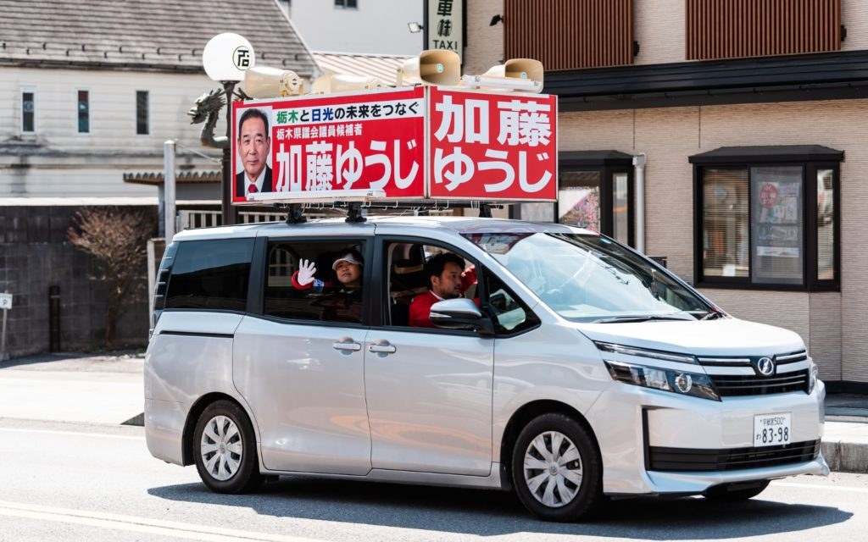
Political campaigning in Japan involves driving around in a van yelling out the name of a politician.
Japanese train stations, in‌ ‌particular, seem to be a haven of noise, with constant overlapping announcements and megaphone-wielding staff. In 2008 a doctor independently measured the sound levels of several stations and found that Tokyo hubs like Ueno and Tameike-Sanno were buzzing around 100 decibels, almost double the WHO’s recommended 53.
Nonetheless, on the surface urbanites appear to have adapted to the cries of the city. As a lover of peace and quiet, I thought I had managed to control my exposure to souon (noise pollution) well, by choosing a relatively quiet place to live.
In search of silence
However, I didn’t realize how much noise we are usually surrounded by until it all went away.
This revelation occurred during a recent business trip to Miyazaki Prefecture, where I stayed in the Sukimu Land area at Karukaya, a grouping of prettily restored traditional thatched houses facing one of Lake Ono’s secluded bays.
Karukaya is seriously off the beaten track, quite a way down from even the infrequently traveled road that connects it to nearby Kobayashi City. As soon as I was dropped off in the valley, I could feel a change. I couldn’t quite put my finger on it until I realized there wasn’t a single-engine noise, announcement, air conditioner whir, rattle of train wheels or person chatting on their phone in earshot.
Just the chirp of crickets, far off trills of cicadas and the occasional cry of a circling hawk. The stillness of the house, emphasized by the thick thatched roof that further blocked sound, was almost shocking.
As the evening progressed, I realized that I was actually listening. Not trying to block out the usual megaphone announcements, or in a mental haze caused by tinny music, cars and train jingles competing for my attention.
Each individual piece of gravel crunching under my feet made a slightly different pitch, and as the stars came out I could distinguish the far off bark of a deer. The brain fuzz that I didn’t even realize was part of my status quo dissipated, and I could literally feel my pulse slow down in the blessed stillness.
Is there a noisier place than the Japanese pachinko parlor?
Noise pollution is harmful to our health
These physical changes are not just due to my somewhat hippy-ish tendencies but are backed up by science. According to research by the American College of Cardiology, noise pollution is linked to an increase in cardiovascular problems. The stress of constant noise results in the more frequent release of cortisol — the infamous stress hormone — which damages blood vessels.
On the flip side, research published in the Brain Structure & Function journal in 2015 may show that silence allows the brain to develop new cells that transform into functioning neurons, basically helping your brain regenerate.
Noise is a surprisingly important part of our wellbeing, and being surrounded by it at all times has potentially severe consequences for physical and mental health. There are those seeking to quiet down the cacophony, but their efforts are limited. The Shizukana Machi wo Kangaeru Kai (literally “group to think about quiet cities”) try to increase awareness of the overwhelming soundscape of many Japanese cities, but on the whole, the public and institutions seem indifferent.

The Japanese culture of noise
Cultural reasons may account for the limited interest in quieting down public spaces. According to research by Daniel Dolan of Tohoku University, Japanese society has a tendency to value the rights of public expression—even when loud, repetitive and annoying — over the rights of citizens who may be affected by the noise.
This tendency is further exacerbated when it comes to organized groups, such as those election and nationalist vans blasting their messages early in the morning.
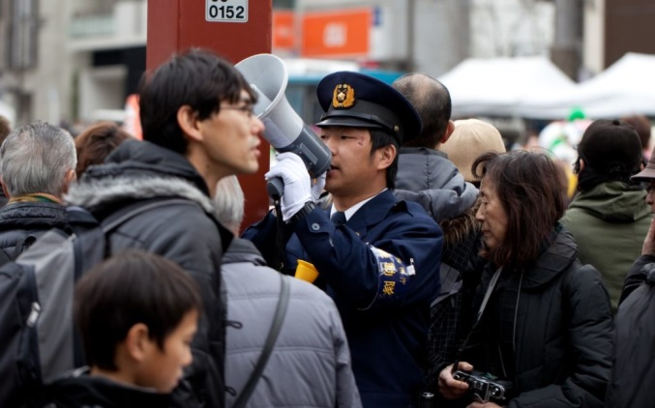No need to shout, I’m right here!
Another point that comes up often in Japanese blogs and articles is that, in a strange way, there is a type of institutional kindness at the heart of the ever-present announcements and warnings in public spaces. Although they may appear a bit nanny-like to those from other countries, the 5 pm neighborhood chimes, or reminders that the train is approaching are meant to help people.
Unfortunately, they have become such a normal part of the soundscape that most ignore them, causing governments and businesses to make their appeals even more piercing in a vicious circle of ever-increasing din.
These two points may help explain the lack of information about noise pollution in Japan. Large scale data available to the public is limited, and most information seems to come from research done by independent groups and concerned individuals, such as the Kawai Foundation for Sound Technology and Music, who share some data on the levels of sound in daily life in Japan on their somewhat retro website.
Whether it is possible to quiet down Japan’s public spaces is a tough question, although there seems to be some increase in recognition of this invisible type of pollution.
In the meanwhile, it’s a good idea for us all to seek silence and protect our ears from the assaults of megaphones and announcements. Certainly, not all of Japan is as chatter-filled as Tokyo, Kyoto or Osaka, so what better excuse for an escape to the quiet of the countryside?
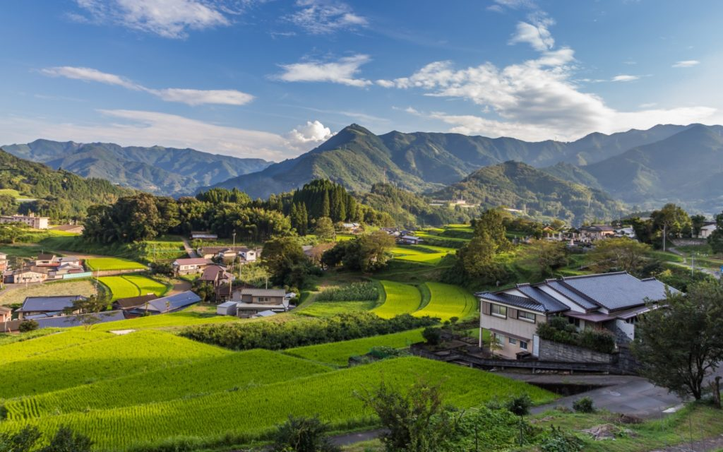
Take me to Miyazaki!

