The very first April Fools’ Day
There are many theories as to the origins of April Fools’ Day, but some historians believe the day originated in 1582 when France switched over to the Gregorian calendar, which changed New Year’s Day from April 1 to January 1. Back in those days, the news took a little longer to reach everyone, and those who were a bit slow on the uptake (celebrating New Year’s Day on April 1, for example) became the target of pranks, including having paper fish glued onto their backs—because fish are easy to catch.
Pasta grows on trees
On April 1, 1957, the BBC TV show "Panorama" ran a segment about the Swiss spaghetti harvest enjoying a "bumper year" thanks to mild weather and the elimination of the spaghetti weevil. Many credulous Britons were taken in, and why not? The story was on television -- then a relatively new invention -- and Auntie Beeb would never lie, would it?
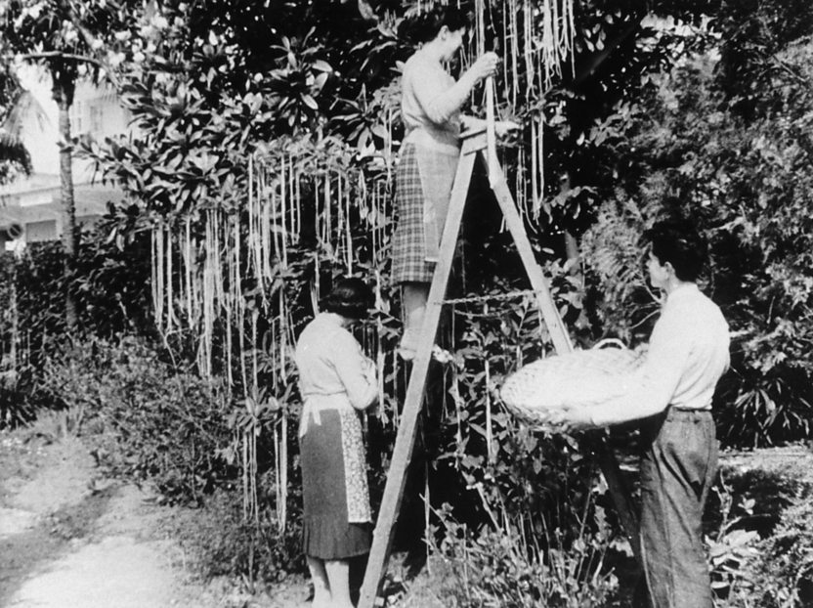

Left-handed toilet paper
Why should right-handers be closer to cleanliness? In 2015, Cottonelle tweeted that it was introducing left-handed toilet paper for all those southpaws out there. The joke followed a 1998 stunt by Burger King about its new "Left-handed Whopper." Few people may have been taken in by Cottonelle, but that wasn't the case in 1973, when Johnny Carson cracked a joke about a toilet paper shortage. Worried Americans immediately stocked up. Well, you can never be too sure.
Big Ben goes digital
Due to on-going renovations, it’s been a while since we’ve heard the bongs of Big Ben. However, it’s been even longer since the BBC Overseas Service (now called the World Service) tried to convince the world that it would change to electronic beeps.
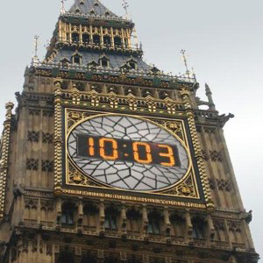
In 1980, they announced to listeners that not only was the iconic clock face going digital, but that the first people to get in touch could win the hands of the clock. Unfortunately, this did not go down as well as they’d hoped and the BBC was apologising for weeks after the joke was made. Some people just clearly didn’t see the funny side!

Color TV? Try nylon
In other TV-related jokes, in 1962, the Swedish national network put on a technical expert who told the public that its black-and-white broadcasts could be made color by viewing them through nylon stockings. Many Swedes fell for the hoax. The Swedish Television channel received dozens of complaints that many pairs of stockings had been totally ruined by being forced over the television, to no effect bar a very difficult to see nylon blurred screen.

Google Gulp
Google loves April Fools' Day almost as much as making doodles. In 2005, the company said it was branching out with a new drink: Google Gulp. It would help "to achieve maximum optimization of your soon-to-be-grateful cerebral cortex." Also, low in carbs!
Add it to fake Google products including Google Romance, Gmail Paper and Google Voice for Pets. But not Gmail itself, however: That was real.
The evolution of the flying penguins.
In 2008 the BBC released a trailer for its highly respected nature documentary series, Miracles of evolution, claiming that the development of flight in Adelie penguins, the most southerly living penguins, was positive proof of Darwin’s theory of evolution. The penguins were not only shown walking in their natural environment, but highly convincing footage fooled many people into believing they were watching the bird’s annual migratory flights to South America.
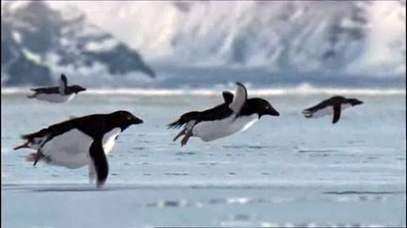
These "miracle penguins" also made it to the cover of The Daily Mirror, which quoted the filmmaker, Prof. Alid Loyas (an anagram for "April Fools' Day"), saying: "We could hardly believe our eyes. It was amazing. It's the perfect example of Darwin's theory of evolution working in reverse."
The newspaper also discussed the other astonishing discoveries made by the filming crew: a lizard which swallows itself to avoid predators, and a musical frog which attracts mates by rapping its legs together. Flying penguins dominated The Daily Telegraph as well. The paper announced that the BBC had "remarkable footage of penguins flying as part of its new natural history series, Miracles of Evolution."
The reports were so convincing that Chris Tryhorn, a columnist for The Guardian, said that the story gave him "pause for thought, mainly because to be an April Fool it would have to have been the result of an unusual three-way collaboration between two rival papers and the BBC." All three organizations worked together in this instance, to put a smile on their audience's faces.
Office Pranks
For most of us though, office pranks are little moments of sunshine that brighten an otherwise dreary work day, and can be played on any day. We asked our readers to tell us about their favourite office pranks.

I have hidden a tiny speaker in an adjacent cubicle wall that emits a soft cat meow every 2 hours.

I sit beside a guy who is a good friend of mine and our desks are separated by a moveable divider. Since I moved beside him 2 weeks ago I've been moving the divider a centimetre towards him each day. We're at 13cm and he hasn't noticed yet.
I have to shift his monitors soon though so that will be interesting.
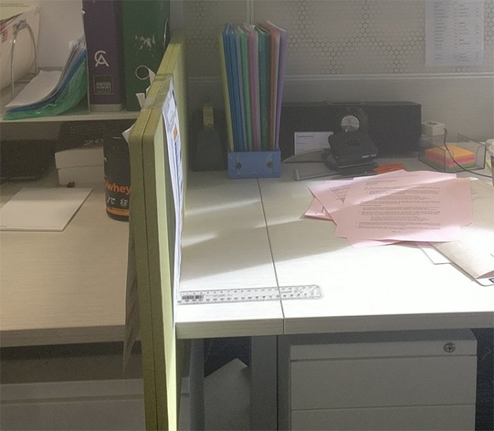

I made 20 copies of a paperclip and put them in the paper tray of copier. A woman in my office made a copy and got the paperclip in the pictures and thought there was a paperclip in the copy machine somewhere. She was searching and searching and even went and got a flashlight and started looking everywhere in the machine. She was opening up drawers and panels for 20 minutes. It was pretty fun to watch.

Once I plugged in a wireless mouse into their computer without them knowing. And a few times a day I would just jiggle the mouse. Just enough to hear them slamming down the mouse and muttering under their breath and I'd stop. This went on for several days. Sometimes I'd stop by to chat, and I would bring the mouse. When they we go to click on something I would just move the mouse just slightly so they couldn't actually hover over what they wanted to click. It was brilliant!

I sent a co-worker I loathed a manila envelope full of glitter. She promptly tore it open.
That was two years ago, and she still finds glitter everywhere. Our lil office fairy.

Leaving sticky notes on their desk that says "Come see me" but no sign as to who it’s from.

When I worked at Burger King we had new employees look for charcoal for the gas grill.

For a while my favourite thing was to unplug their mouse & put a sticker under the mouse sensor.
Was great when people plugged it back it and it still didn't work...

Did you ever grow cress as a child?
It’s so easy to plant, that it could pretty much grow anywhere; in potatoes, in cotton wool, or in a computer keyboard!
