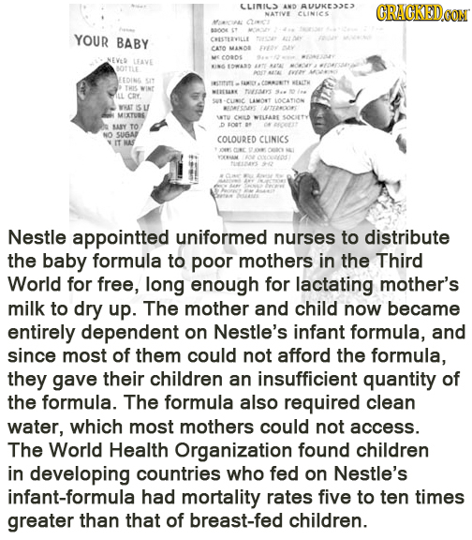
Diabolical Acts of Evil by Famous Corporations

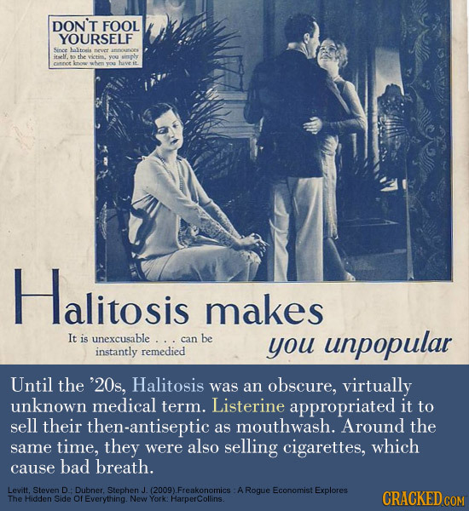

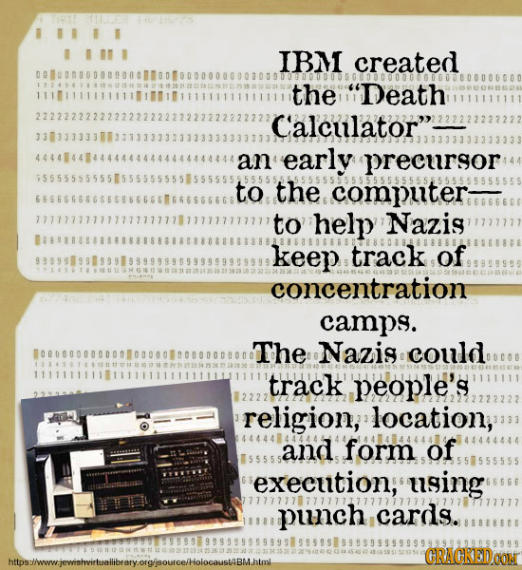

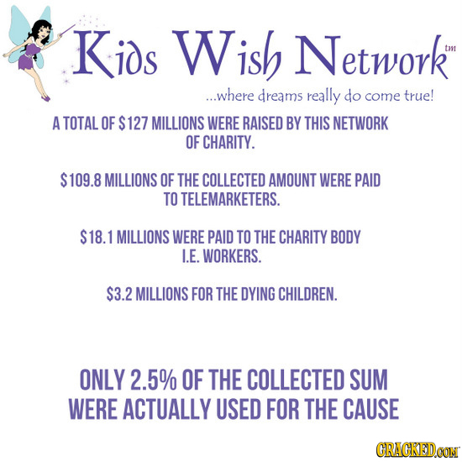

Coca-Cola Has A Whole Program Devoted To Eliminating Tap Water From Restaurants
In 2010, the Coca-Cola Company proved its deep sense of social responsibility by turning its attention to one of the worst problems ravaging America: restaurants losing revenue because too many people are saying "Just water, please" instead of "Gimme a Coke." Being its ever-woke self, the company decided to help. Thus was born Cap the Tap, a program billed in its official website as "a campaign to end water waste." Coca-Cola's own written materials, however, betray a somewhat less altruistic goal: to teach "crew members or wait staff suggestive selling techniques to convert requests for tap water into orders for revenue-generating beverages."

.The program trains and incentivizes waiters to first push diet sodas, iced teas, and smoothies on customers, but if the stubborn customers insist on drinking water, then it should at least be of the bottled type (like, oh, Coca-Cola's Dasani, for instance). What's so absurd about all of this is that a one-liter bottle of water takes more water to produce than it contains. Bottled water is also environmentally disastrous, sometimes worse for kids than tap water (which is better regulated and safer), and is in fact often tap water itself.

BAYER

You may recognize Bayer as the maker of Aspirin. They’re one of the top pharmaceutical companies in the world. In 1984, they discovered that one of the products they were selling—a medicine to induce blood clotting—was infecting people with H.I.V. So like any responsible company, they stopped marketing it and developed a safer medicine—right before exporting all of the contaminated medicine to Asia and Latin America, where it continued to be sold. They even continued making the H.I.V. infected medicine for another few months, because it was cheaper to produce than the new version—this was again sold straight to developing countries.
Six thousand people in the US were known to have contracted H.I.V. and AIDS from the medicine—but how many died from the tainted medicine overseas? At least 100,000 units of the medication made their way to Asia and Argentina after Bayer stopped selling it in America.

