The Fax Machine Was Invented The Same Year The First Wagon Crossed the Oregon Trail (1843)
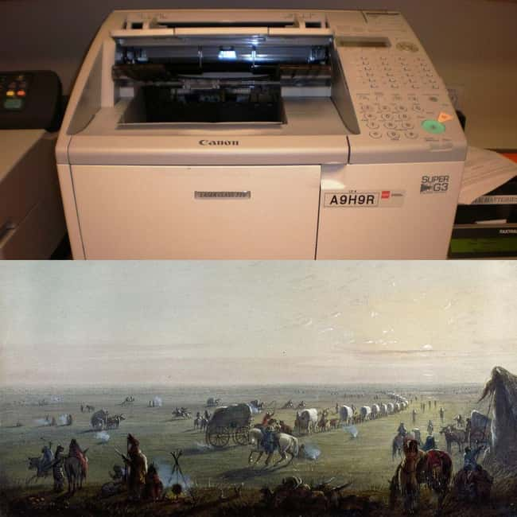Photo: BrokenSphere / Alfred Jacob Miller
It sounds crazy, but it's true: RedditFed points out that Scottish inventor Alexander Bain received the patent for the “Electric Printing Telegraph” – the granddaddy of the modern fax machine – on May 27, 1843. That same year, in what’s now known as the “Great Migration of 1843,” about 1,000 emigrants headed to Oregon via wagon train on the Oregon Trail.

Woolly Mammoths Were Still Alive While Egyptians Were Building The Pyramids (2660 BCE)
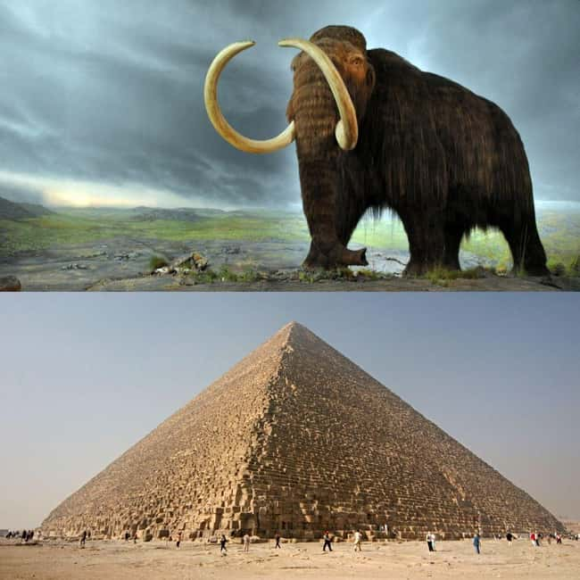
Photo: Flying Puffin / Nina Aldin Thune
Ice Age might get a few more sequels: a small population of woolly mammoths lived on Wrangel Island – a Delaware-sized island about 90 miles off the coast of far eastern Siberia – until about 1650 BCE. The oldest of the so-called “Great Pyramids” in Egypt was constructed between 2667 and 2648 BCE, meaning that yes, as Redditor LastKill stated, there were actually woolly mammoths alive and well when the Great Pyramids were being built.

You Could Take The London Underground To The Last Public Hanging In The UK (1868)
Photo: mattbuck / Fraser Mummery
Two Redditors (TheFairyGuineaPig and Iamreeve) drew readers' attention to this startling fact: the last public hanging in the UK took place on May 26, 1868, when Michael Barrett was executed in front of a crowd of two thousand people outside the walls of Newgate Prison in London.
The Barbican London Underground station was built in 1865 (as Aldersgate Street) and is only a 10-minute walk from Newgate Prison (now the Central Criminal Court), according to Google Maps. This means it was entirely possible that Londoners took the tube to watch a hanging.

Prisoners Arrived At Auschwitz Just Days After McDonald's Was Founded (1940)
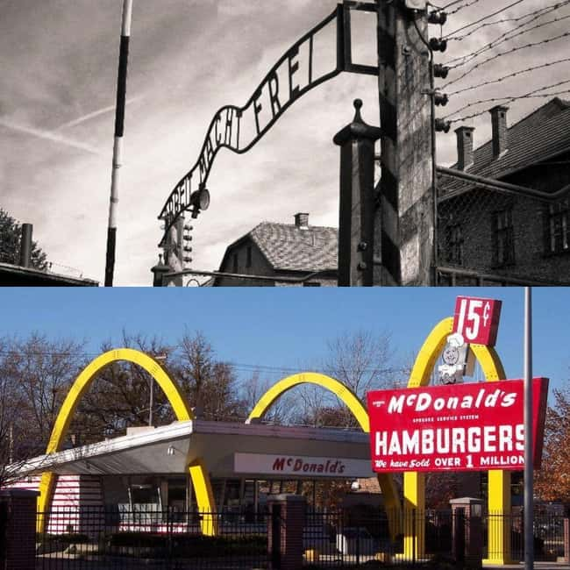
Photo: PerSona77 / Bruce Marlin
Most people connect McDonald’s with post-WWII America – and it's true that the chain really took off at that time – but brothers Richard and Maurice McDonald actually opened the first McDonald’s restaurant on May 15, 1940, in San Bernardino, CA. Reddit user Shieee points out that just five days later, the first concentration camp prisoners arrived at Auschwitz.

The Ottoman Empire Existed The Second To Last Time The Chicago Cubs Won The World Series (1908)
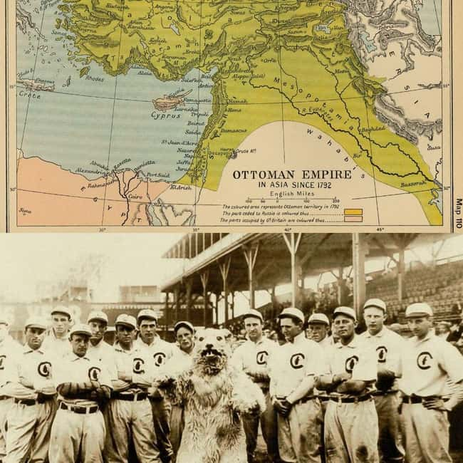
Photo: Ethnologue Philologue / George R Lawrence
Yep: the penultimate time the Chicago Cubs won the World Series was in 1908. That’s 10 years before the Ottomans were defeated in World War I and 14 years before the dissolution of the Ottoman Empire. This means the Cubs’ second-to-last big win is older than Turkey.

Nintendo Was Founded When Jack the Ripper Was Still On The Loose (1889)
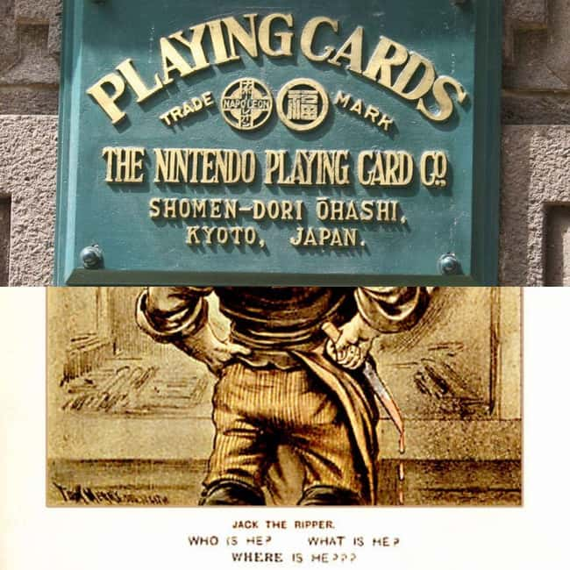
Photo: Eckhard Pecher / Tom Merry
Japanese gaming giant Nintendo was founded on September 23, 1889, originally producing handmade playing cards called hanafuda. This means the company behind Mario, Donkey Kong, Samus, Kirby, and that copy of Wii Sports gathering dust in your parent’s basement was actually contemporaneous with the legendary London serial killer Jack the Ripper. Though all the murders we now attribute to the killer were committed in 1888, in September 1889, Londoners still thought Jack was on the loose: he was a suspect in the murder of unidentified woman – called “The Pinchin Street Torso” because all they found was her torso – just a few weeks before Nintendo was founded.

By The Time The Pilgrims Made It To Plymouth Rock, There Was A 'Palace of the Governors' In New Mexico
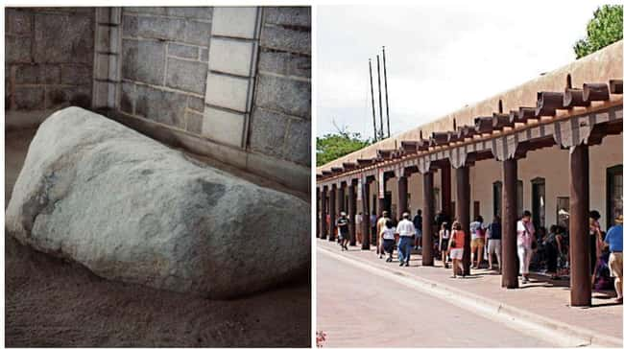
Photo: Wikimedia Commons / Wikimedia Commons
In the basic narrative of the formation of the United States that you get in school, the story begins with the hardy, faithful Pilgrims boarding their ships in England and sailing until they hit Plymouth Rock, MA. While the Pilgrims were a pretty early group of settlers to New England (they landed in 1620), they were in no way the first group to set up shop in the would-be US of A. In fact, Spanish explorers and conquistadors had been establishing themselves in the Southwest for a century before the Pilgrims arrived, and, by 1610, they had built the Palace of the Governors in Santa Fe where they had a full-on settlement.
So all those stories of harsh winters, Native American raids, and barely surviving up North? They should've gone on down to old Santa Fe.

Star Wars Came Out The Same Year As The Last Guillotine Execution In France (1977)
Photo: Rob Bogaerts / Johann Jaritz
Hamida "Pimp Killer" Djandoubi was beheaded via guillotine in France on September 10, 1977, for the torture and murder of a 21-year-old woman. It was the last time France executed anybody using any method – François Mitterrand abolished the practice in 1981. This means that, as Redditor LastKill highlights, in the same year a man in a First World country was getting his head chopped off by the state, kids across the globe were lining up to see Star Wars, which debuted in the U.S. on May 25, 1977, and in the UK on December 27, 1977.

Swiss Women Got The Right To Vote The Same Year The US Drove A Buggy On The Moon (1971)
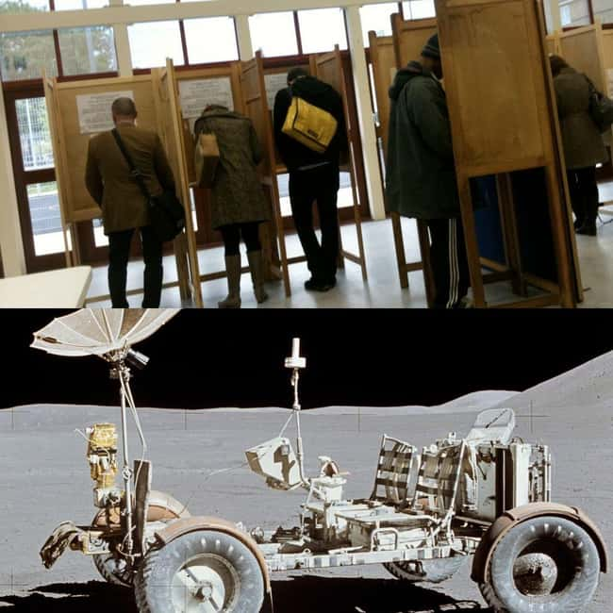
Photo: Alex Lee / Dave Scott
Women in Switzerland couldn’t vote until 1971, largely because Switzerland requires national referendums for constitutional change, and the only people that could vote in those referendums at the time were men. That’s 65 years after Finland became the first European country to grant women the right to vote and 51 years after America made it happen. Speaking of America: in 1971, the US was up on the moon driving a “moon buggy” around.

Microsoft Was Founded While Spain Was Still A Fascist Dictatorship (1975)
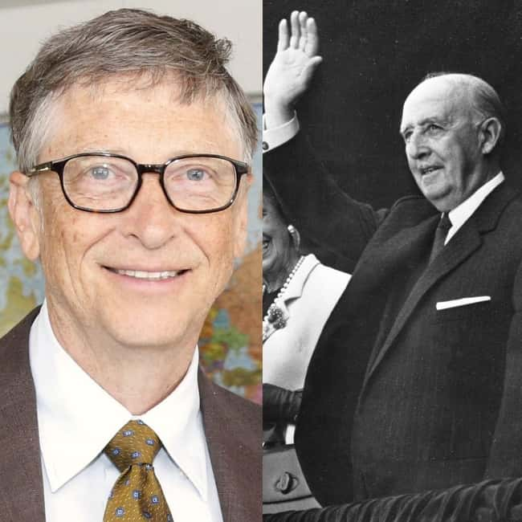
Photo: DFID / Anonymous
Reddit user ampellang drew an odd parallel: when Microsoft was founded by Paul Allen and Bill Gates in April 1975, Spain was still ruled by fascist dictator Francisco Franco, who “presided over a regime of state terror and national brainwashing through the controlled media and the state education system,” according to the BBC.
Unlike Germany or Italy, Spain did not go through a “denazification process” following WWII, meaning fascist politics reigned right up until the early years of home computing.

The Brooklyn Bridge Was Being Built During The Battle Of Little Bighorn (1876)
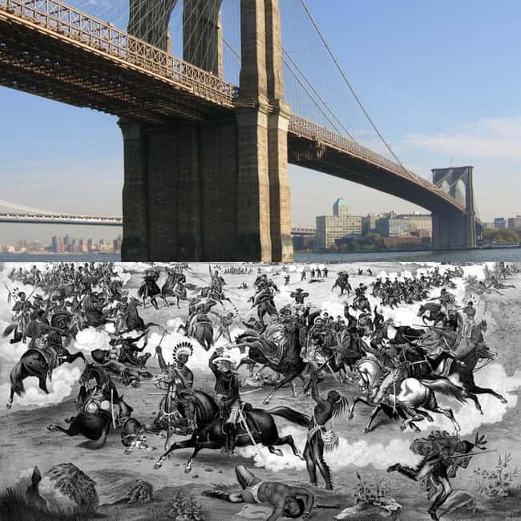
Photo: Postdlf / Seifert Gugler & Co.
Construction on the Brooklyn Bridge – the first steel-wire suspension bridge ever – was, surprisingly, contemporaneous with “Custer’s Last Stand” at the Battle of Little Bighorn in 1876, as Redditor LastKill pointed out. The bridge was still six years from completion when George Armstrong Custer and his men were defeated by Crazy Horse and members of the Lakota, Northern Cheyenne, and Arapaho tribes in eastern Montana territory.

Oxford University Existed For Hundreds Of Years Before The Aztec Empire Was Founded (1428)
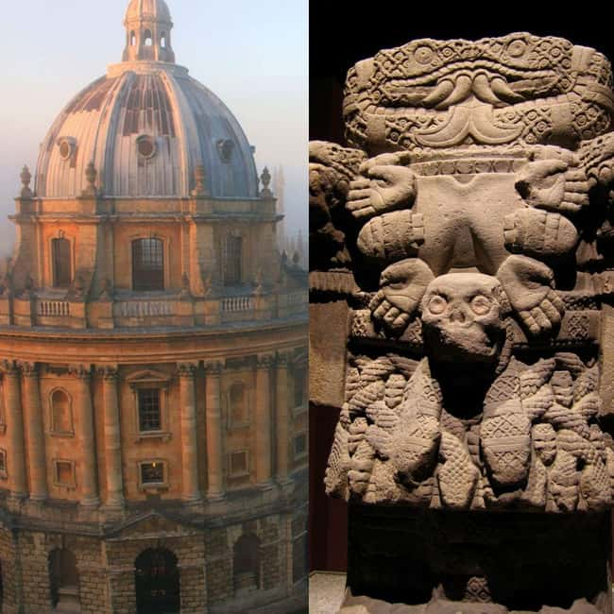
Photo: Tejvan Pettinger / rosemania
Historians consider 1428 to be the first year of the Aztec Empire, which ruled the Valley of Mexico until 1521. Oxford University in England, believe it or not, is actually hundreds of years older than the Aztecs, as Redditor LastKill brought to light. According to Oxford’s website, “teaching existed at Oxford in some form in 1096 and developed rapidly from 1167, when Henry II banned English students from attending the University of Paris.”

