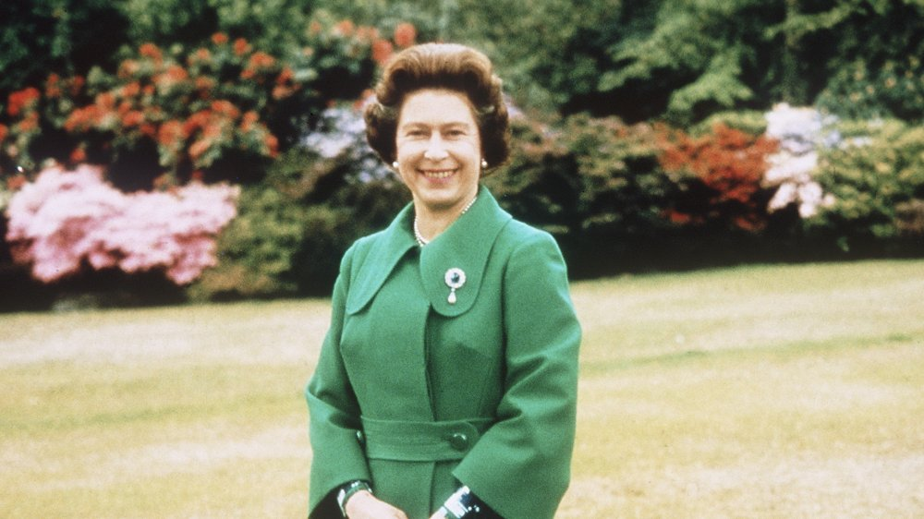
Things Queen Elizabeth Has Never Been Allowed To Do
What has Queen Elizabeth II never been allowed to do? The royal is the longest ruling monarch Britain has ever seen, and in the Netflix series The Crown, viewers got an inside glimpse into what her life might be like behind the scenes. The series follows the Queen as she navigates the singularly unusual job of ruling a country. If The Crown shows us anything, it's that being Queen of England isn't always as much fun as we dreamed it might be when we were kids.

Additionally, the British press has long been obsessed with the royal family, as they are constantly plagued by members of the paparazzi. Tragically, this phenomenon even contributed to the death of Princess Diana in 1997.

Not only is the public always watching the royals, but Queen Elizabeth is also expected to be a symbol of British values like unity, pride, stability, and continuity. To that end, as an important member of the royal family, it's no surprise that the Queen can't exactly do as she pleases. In fact, there are plenty of things that Queen Elizabeth has never been allowed to do. Read on to find out what they are!
Queen Elizabeth has never been allowed to have political opinions
In the UK, all citizens have the right to express their political opinions – that is, almost all of them! It turns out, Queen Elizabeth is expected to remain "strictly neutral with respect to political matters," according to the royal website. This also means that the Queen can't vote or stand for election.

Usually, Queen Elizabeth — who's undergone a stunning transformation — does an excellent job of keeping her political views private. Of course, just because she's never been allowed to have public political views, it doesn't mean she doesn't have them.

In fact, on a few rare occasions, Queen Elizabeth may have broken the rule slightly (via the Independent). For instance, back in 1976, Queen Elizabeth let slip her opinions on American independence, saying, "We lost the American colonies because we lacked the statesmanship to know the right time and the manner of yielding what is impossible to keep." In another instance, the Queen made a thinly veiled political comment about the Scottish referendum, saying, "Well, I hope people will think very carefully about the future."
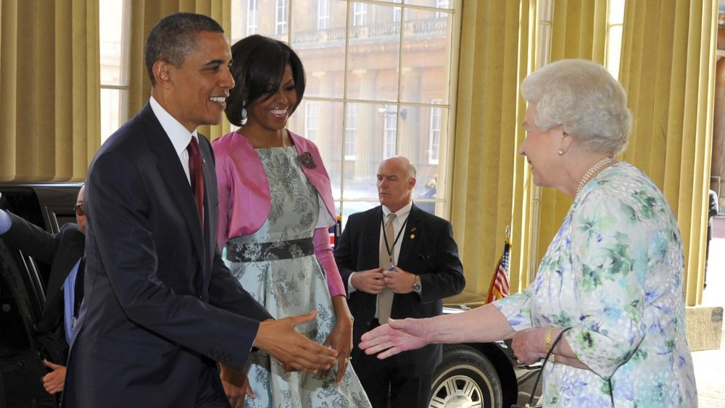
Queen Elizabeth has never been allowed to be touched by a "commoner"
It turns out that members of the royal family, including Queen Elizabeth, aren't allowed to be touched by the "common folk." As Reuters explained, physical contact is actually one of the "greatest taboos surrounding the British monarch." Lucy Hume, the associate director of Debrett's, an etiquette coaching company, said it's "best not to initiate personal physical contact with a member of the royal family."

Of course, this rule doesn't mean that Queen Elizabeth has literally never touched anyone from outside of her family. Sometimes, in fact, Queen Elizabeth has actually welcomed contact with people. For instance, she was once pictured with her arm around Michelle Obama, which CNN said was a "very significant gesture."

Obama later recalled in the moment in her memoir Becoming, writing that she didn't realize at the time the touch was "an epic faux pas" (via Business Insider). We think it's safe to say that similar moments have occurred over the years, and that Queen Elizabeth has probably had her fair share of physical contact with others — but not nearly as much as most of us!

Queen Elizabeth has never been allowed to choose who she talks to at a dinner party
For most of us, dinner parties are a chance to relax, catch up with friends, and enjoy some good food. For Queen Elizabeth, however, dinner parties have never been that relaxed. As it turns out, the Queen has actually never had the freedom to choose her conversation partner at formal dinners. The rule is that Queen Elizabeth begins dinner speaking to the person on her right, and then switches to the person on her left — no shouting across the table allowed at the palace!

Formula 1 star Lewis Hamilton found out about the dining etiquette rule the hard way. As he explained on The Graham Norton Show, he was seated next to Queen Elizabeth at a lunch gathering. Apparently, he started to talk to her, and she said, "You speak that way first, and I'll speak this way, and I'll come back to you." We can't imagine always having such strict rules at the dinner table!

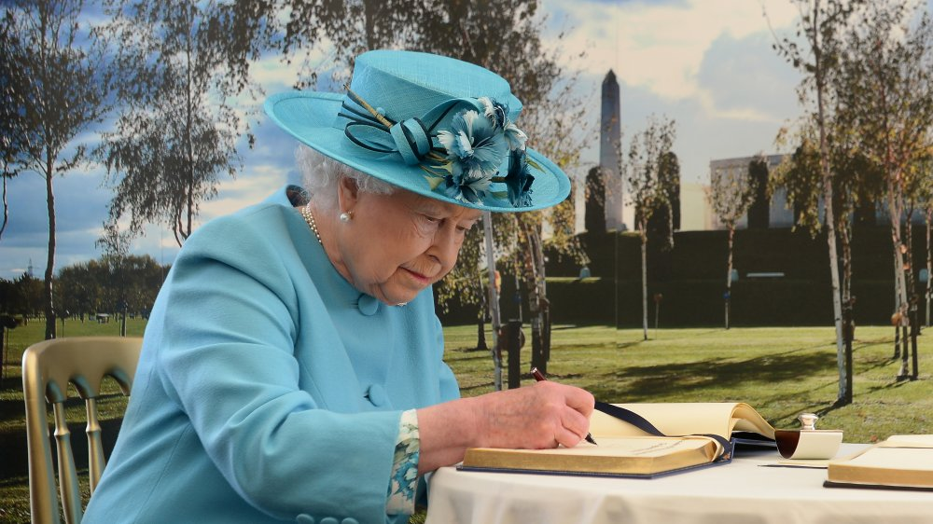
Queen Elizabeth has never been allowed to sign her autograph
There's no doubt about it — Queen Elizabeth is definitely a celebrity! However, unlike other celebrities, the Queen has never been allowed to sign her autograph. According to Express, the royal family is banned from signing their names for fans in case their signature is forged later on. There have been a few accounts of Meghan Markle, Prince Harry, and Prince Charles breaking the no-signature rule — but what about the Queen? Has she ever scrawled her name for an adoring fan?

By the sound of things, Queen Elizabeth rarely signs her own name, period. In fact, in 2020, the Daily Mail reported that an old 1954 Christmas card from the Queen and her husband Prince Philip was worth a staggering £4,500 (around $5,800), simply because Queen Elizabeth's signature is so rarely seen. It seems that the only way to get your hands on the Queen's autograph is to get sent a handwritten holiday card!
Queen Elizabeth never had the freedom to choose her children's names
For most expectant mothers, the joy of selecting a baby name is one of the most fun parts about bringing a child into the world. Sadly, Queen Elizabeth never had the freedom to choose baby names the way most of us have. According to The Oprah Magazine, the Queen is mother to four children: Charles, Anne, Andrew, and Edward. And while she probably had some say in her children's names, there were definitely a lot of other factors that went into the decision.

As Vogue explained, royal baby names are a pretty serious business; they have to both acknowledge history by paying respects to relatives, while also being fashionable. That was certainly the case with Meghan and Harry's shortlist of royal baby names.

The complexities of naming a royal baby don't stop there, either, as most royal tots end up with multiple middle names to pay homage to various relatives. For instance, Prince Charles' full name is Charles Philip Arthur George. That's three middle names! It's pretty clear that Queen Elizabeth had a pretty unusual experience of naming her children compared to the rest of us!
Queen Elizabeth has never been allowed to show PDA
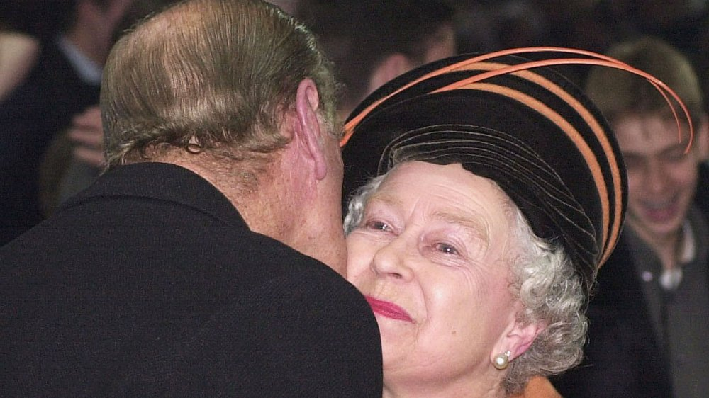
Unfortunately for Queen Elizabeth, public displays of affection (PDA) are strictly off-limits as a matter of custom. As royal etiquette expert Myra Meier told People, "Senior members of the royal family would likely not be told how to interact or when they can or cannot show PDA, and would be trusted to use their better judgement as to when it's appropriate." So the unspoken no PDA rule is generally thought to be linked to the fact that the royals are often out in public in an official capacity, and hugs and kisses would simply be inappropriate.

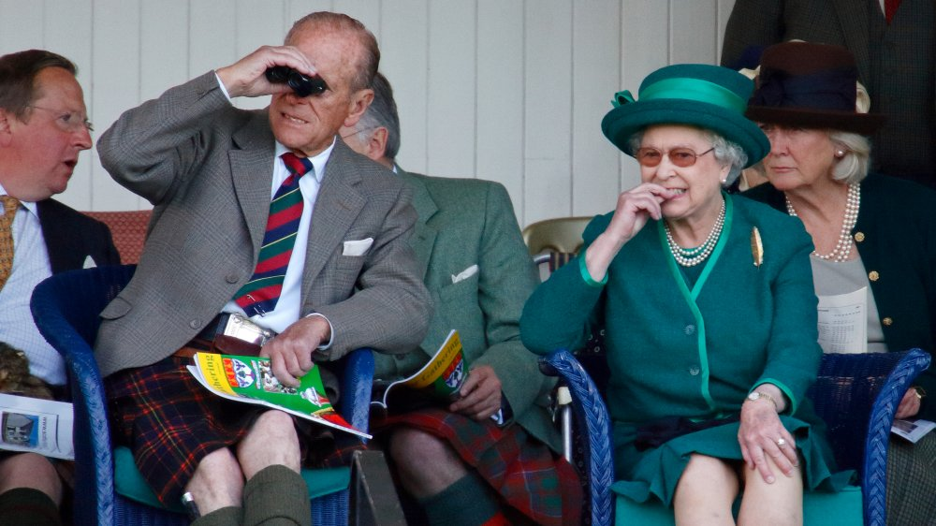
Naturally, couples like Meghan Markle and Prince Harry, or Kate Middleton and Prince William have broken the rules a few times (via Cosmopolitan). But what about Queen Elizabeth? Would she ever be caught sharing a moment of affection with her husband, Prince Philip? Well, according to Express, way back in 1953, Philip kissed the Queen during her coronation. And, in 1991, he kissed her on the cheek during New Year celebrations. But aside from a handful of other pecks, the Queen has kept her romantic life decidedly private.
Queen Elizabeth has never been allowed to cross her legs

One of the strictest royal rules the family has to follow has to do with how women are allowed to sit, though there are some insane rules that royal children have to follow, too. Remember in The Princess Diaries when Mia is taking princess lessons, and can't figure out how to sit with her legs crossed elegantly at the ankles? Well, it turns out, members of British royal family are all expected to sit this way in real life (via Reader's Digest)!

Royal etiquette expert Myra Meier, who covered classic royal positions in her book Modern Etiquette Made Easy: A Five-Step Method to Mastering Etiquette, explained that she called the common female sitting position in the royal family the "Duchess Slant." The sitting position involves keeping the knees firmly together while tilting the legs to the side (via the Daily Mail).

It's hard to imagine seeing Queen Elizabeth with her legs crossed these days. As she said on the ITV documentary, Queen of the World, sitting cross legged is "quite painful" (via Express). However, it turns out, she broke the unspoken leg-crossing rule a few times in her youth when she was a little more sprightly!
Queen Elizabeth has never been called "Liz" in public
For many of us, our given names are seldom used in our daily lives. Nicknames and short-form names have become a staple of modern life, with almost everyone going by a shorter version of their full name.

However, for members of the royal family, using a nickname isn't really allowed. According to Good Housekeeping, all royal family members are expected to go by their full names in public — anything less would be inappropriate.
Nevertheless, this doesn't mean that Queen Elizabeth and her family don't have private nicknames for each other. In fact, there are plenty of secret nicknames royals have behind closed doors. According to Vogue, Queen Elizabeth was called "Lilibet" while she was growing up. Additionally, her husband, Prince Philip often calls her, "Cabbage" (via Hello!). And when Prince William was a child, he reportedly called her, "Gary," as he couldn't say "Granny".

Queen Elizabeth has never been allowed to enter the City of London without permission
Even though Queen Elizabeth is the ruling monarch of Britain, it turns out, she's not actually allowed to step foot inside the City of London without permission. According to The New Statesman, the City of London operates separately from the rest of the country — some even call it the British Vatican!

Whenever the Queen wishes to enter the City of London, the city's police force puts up a red cord. An extravagant ceremony follows, in which several officials assist, including someone called "the Remembrancer." Apparently, the Remembrancer is "charged with maintaining and enhancing the City's status and ensuring that its established rights are safeguarded." So along with other City of London officials, the Remembrancer is responsible for giving the Queen permission to enter the City. Apparently, the tradition dates all the way back to the reign of Queen Elizabeth I!
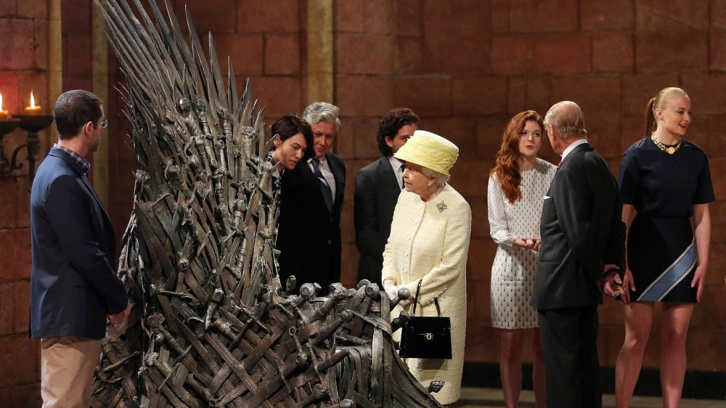
Queen Elizabeth has never been allowed to sit on another monarch's throne

One of the rules Queen Elizabeth must follow is to never sit on another monarch's throne. While the opportunity probably doesn't arrive very often, Queen Elizabeth did have to follow the rule in one surprising instance. Apparently, when she visited the set of the HBO series Game of Thrones, Queen Elizabeth refused to sit on the show's Iron Throne!

Actress Maisie Williams, who's undergone a stunning transformation, and who portrayed Arya Stark in the show, spoke about the humorous incident on the YouTube series First We Feast. "She sort of looked at it and said, 'That doesn't look very comfortable,'" Williams shared. While no one actually asked Queen Elizabeth to sit down, Williams recalled that, "We all just sort of smiled and were like, 'Is she going to do it?'"

While we aren't sure the fictional Iron Throne counts as another monarch's throne, we love this story about the Queen following the rules!
Queen Elizabeth has never been allowed these things at dinner
What does Queen Elizabeth typically eat in a day? When it comes to foods, the royals have a surprising number of rules and regulations. So while you may be tempted to think that eating like a king or queen means eating anything and everything your heart could desire, this is far from the case in reality. Apparently, Queen Elizabeth and her family are never allowed to eat or drink a wide variety of items, including shellfish, garlic, and even tap water (via Mashed).

According to BBC News, the ban on shellfish is in place in case of digestive issues that can interfere with public engagements. Foreign tap water is also not allowed for the same reason. Garlic is reportedly off limits, too, according to a former palace chef (via Food & Wine). It sounds like Queen Elizabeth has a few strange and surprising food limitations — everything is not on the menu for the royals.
Queen Elizabeth has never been allowed to look messy
In addition to food rules, there are beauty rules the royals are forced to follow, too. There's a reason why we never see paparazzi shots of Queen Elizabeth and her family in their sweats and sneakers!

First of all, Queen Elizabeth has never been allowed to grow long nails. As sources told OK! magazine, long, colorful nails are an absolute no-no in the palace. Additionally, Queen Elizabeth has to be mindful of her hair and makeup. According to Vogue, royals must always have neat, healthy-looking hair, while makeup should be "minimal, modest, and natural."

However, this royal rule doesn't mean that Queen Elizabeth can't experiment with makeup looks. In fact, the Queen is apparently a big lipstick fan! As Harper's Bazaar noted, the Queen even has her own signature pink color, while all of the other ladies in the court select more muted tones. And according to Marie Claire, Queen Elizabeth even commissioned her own shade for her coronation! We love that the Queen has always followed the royal beauty rules — but has retained some self-expression at the same time!

Queen Elizabeth has never been allowed to drive herself to a royal engagement

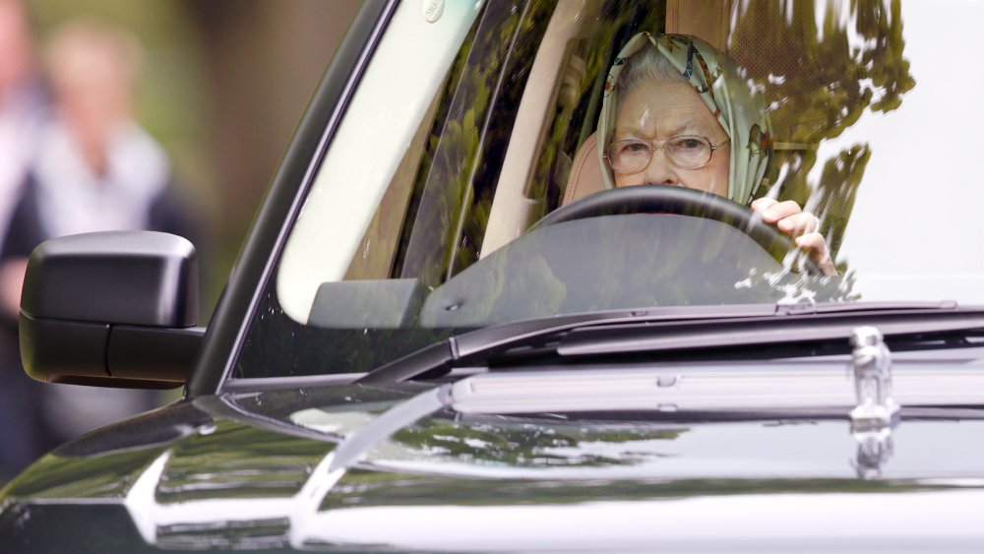
One of the greatest pictures of all time has to the 2017 snap of Queen Elizabeth driving herself and her security guard home from church (via Elle). While it's rare to see the Queen behind the wheel, she actually reportedly loves to drive (via Popular Mechanics), having learned while serving in the Women's Auxiliary Territorial Service during World War II (via The Sun). Nevertheless, it turns out, Queen Elizabeth probably doesn't get to drive nearly as often as she'd like to. As Duncan Larcombe, a previous royal correspondent for The Sun, told Town and Country, "when they're on official business," members of the royal family "are always driven to and from their appointments."

Even when the royals do get to drive by themselves, they're never really alone. "They'll still have their protection officers in tow," Larcombe explained. "They would have had at least two vehicles driving with them and a protection officer in the vehicle with them, all armed." Yikes! It sounds like Queen Elizabeth rarely gets to enjoy the open road like the rest of us!
Queen Elizabeth has never been allowed out in public without at least five armed guards
It's not just in the car that Queen Elizabeth is surrounded by security guards. As it turns out, the Queen has probably never been out in public without security guards at her side! According to Mirror, each royal always has "up to five highly-trained armed officers to look after them." And when Queen Elizabeth visits her Scottish palace Balmoral, she's apparently joined by dozens of officers. Fun fact: the Queen's security team refers to her as "S" when she's out and about. Some think that it may stand for "Sharon" (via The Scottish Sun).

In 1974, Princess Anne, Queen Elizabeth's daughter, was almost kidnapped, but was saved by her security guard (via Tatler). And, when the Queen was visiting Jamaica, her guards had to rescue her from an overly adoring crowd, according to an ITV documentary (via Express).

While this level of constant security may sound a little over the top, based on these incidents in the past, it's probably necessary for Queen Elizabeth's safety.

