Things We Didn't Know We Were Calling By The Brand Name
Many of the things we use daily, such as zippers as well as escalators, were formerly big brands. Perhaps heroin, which should never be used, had a brand name. These trademarks are or have been copyrighted, but they're now commonly used to refer to any company in a particular product area.

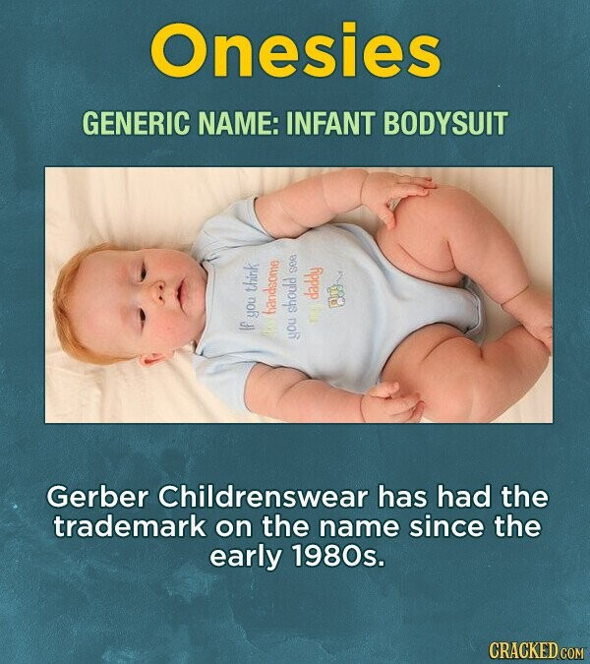
Source: Gerber
Continue Reading Below

12
Source: Mental Floss

11
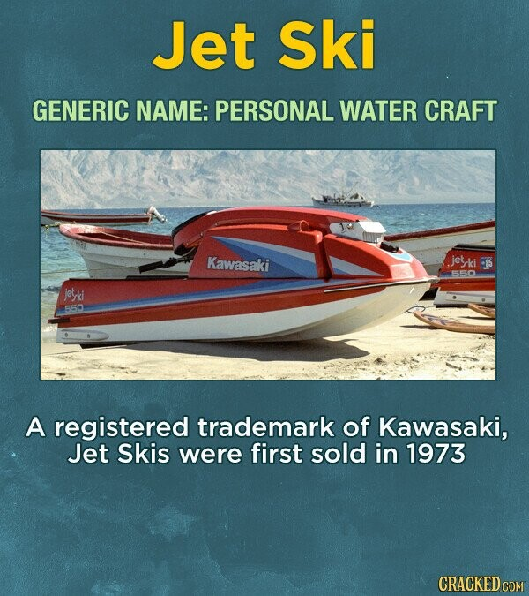
Source: Kawasaki

10
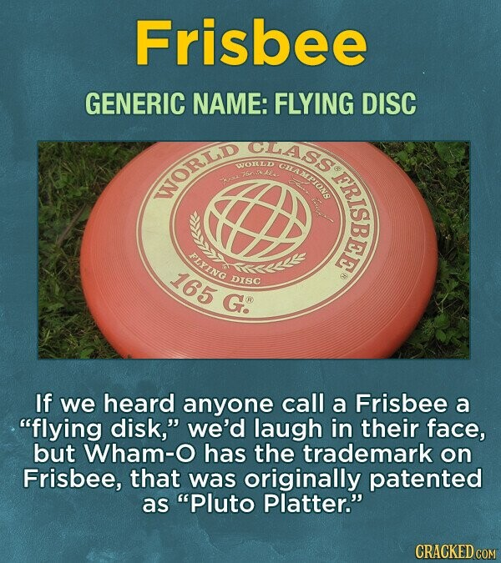
Source: Funding Universe

9
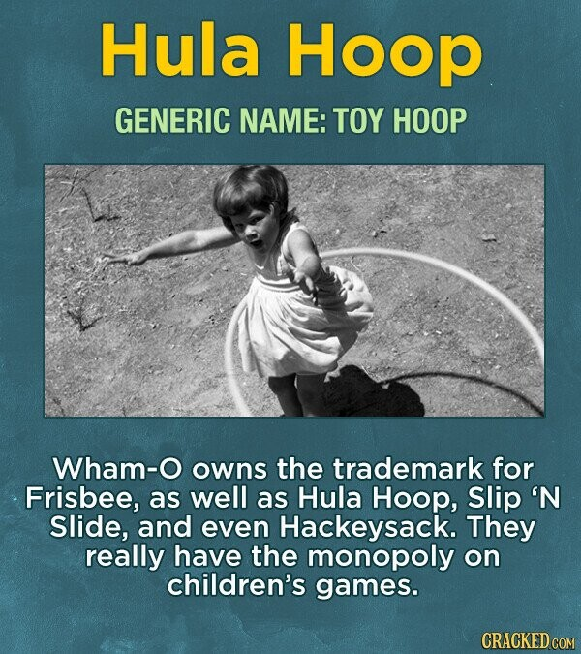
Source: Westlaw

8
Source: Justia Trademarks

7
Source: Swiss Broadcasting Corporation

6
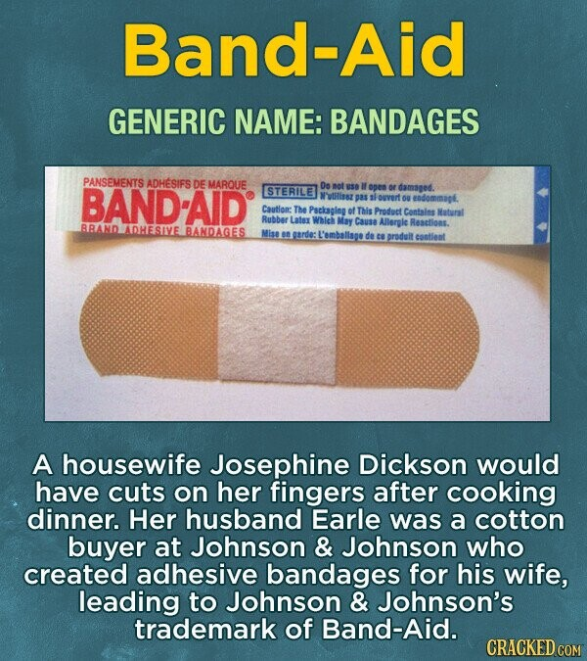
Source: Band-Aid

5
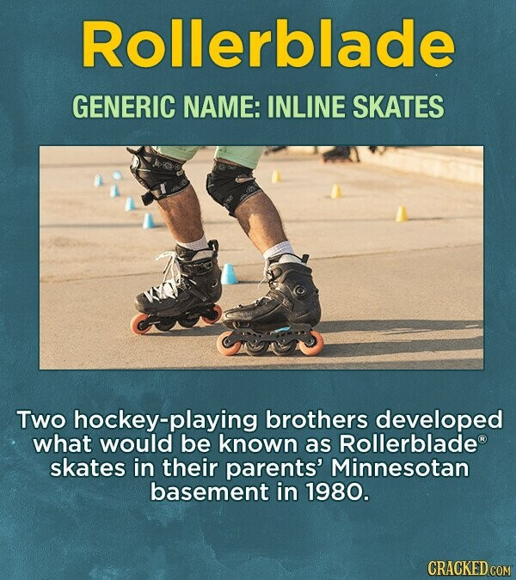
Source: Rollerblade

4
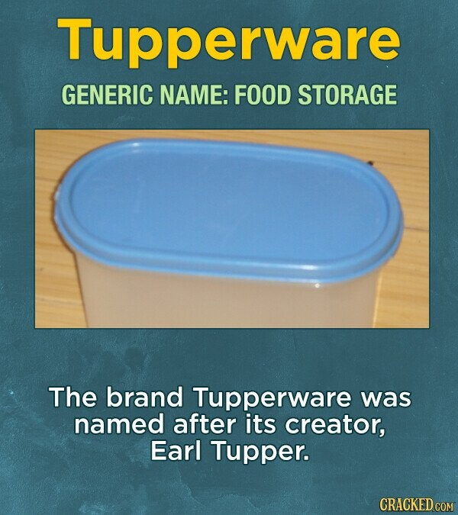
Source: New York Times

3
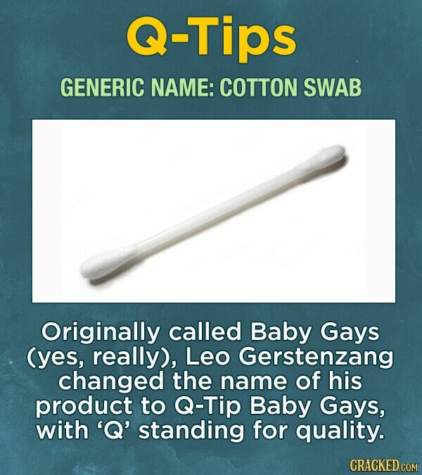
Source: Q-Tips

2
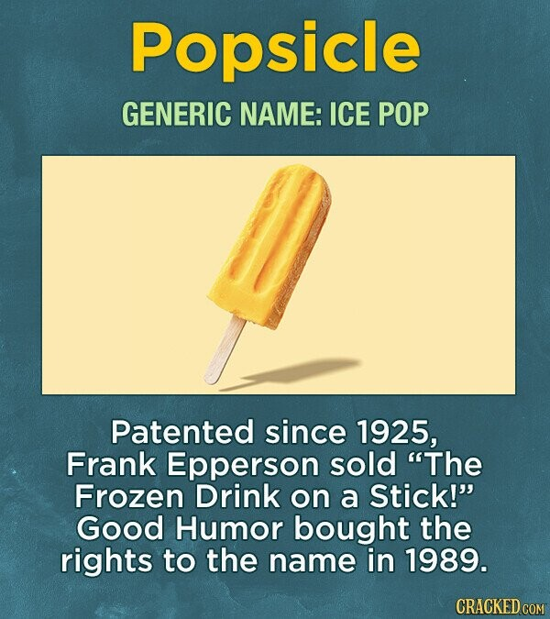
Source: The Atlantic

1
Source: Dow Chemical Company

