Ubasute: Is the Ancient Tradition of Dumping the Elderly in a Forest Encouraging Modern Murder?
basute is an ancient practice from Japanese folklore in which a sick or elderly relative is dumped in a remote place to die. Although ubasute is attested in a number of Japanese legends, it is unclear if it was actually a common practice in the past. There is evidence today that ubasute is being ‘revived’ in modern day Japan, albeit in a slightly different form. .
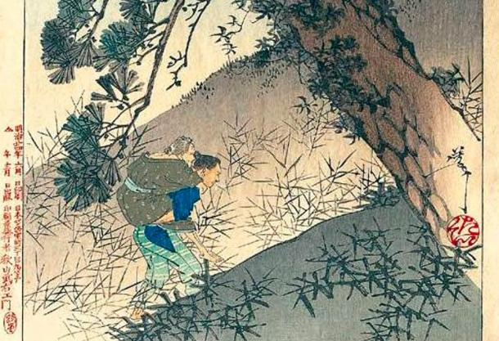
The abandoned old woman. Source: Catfisheye / Public Domain .

A Form of Senicide
Ubasute is known also as obasute and literally translates to mean ‘abandoning an old woman’. Alternatively, it is known also as oyasute, which means ‘abandoning a parent’. Ubasute is a form of senicide (the killing of the elderly) and involves leaving the elderly person on a mountain or some other desolate place to die. One such place believed to have been a popular site for ubasute in the past is the dense forest at the northwest foot of Mount Fuji , which is known as Aokigahara (known also as Jukai, meaning ‘Sea of Trees’).

Legends of Ubasute
Ubasute is the subject of a number of Japanese legends. Although these tales appear to be about the abandonment of the elderly, they are in fact meant to inspire filial piety and to discourage people from abandoning their elderly parents. One of the best-known ubasute tales, for instance, is known as Ubasuteyama, meaning Ubasute Mountain. In this folktale, an elderly mother is carried by her son up a mountain, where he intends to abandon her. Although the mother is aware of what her son is doing to her, she still cares for him and scattered broken twigs on the ground so that he would be able to find his way down the mountain. The story highlights the love that a mother has for her children, which in itself is a poignant argument against ubasute.
Another tale, which came from India (along with Buddhism) via China during the 6 th century, speaks of a king who hated the elderly. This king instituted a kind of state-sanctioned ubasute, in which any of his subjects who lived past the age of 70 were sent into exile. One of his ministers loved his mother so much that when she turned 70, he dug a secret underground chamber in his house and hid her there. Some years later, the ruler of a neighboring kingdom sent two almost identical horses to the king, with a riddle asking him to identify the parent and the offspring. If the king failed to answer this riddle his kingdom would be attacked. The king sought the advice of his minister who promised that he would find a solution to the riddle.
Although the minister was not able to answer the question himself, he knew someone who might be able to. He went to his mother, who having lived for so long, might have heard of such a riddle. The elderly woman had heard of this riddle before and told her son to place grass before them. The horse who steps back and lets the other eat, she said, is the parent. More riddles followed and each time the minister sought his mother’s advice for the answer. Eventually, the neighboring ruler gave up his plans to attack and became an ally of the king. Impressed by his minister, the king summoned him to find out how he knew all the answers. The minister confessed all that he had done. Instead of getting angry, however, the king saw the error of his ways, revoked his decree against the elderly, and honored them appropriately.

Is Ubasute Folklore or Reality?
The practice of ubasute is largely confined to the realm of folklore, as there is insufficient evidence to show that it was widely carried out in the past. Nevertheless, these stories have inspired modern day acts of ubasute, as there are reports that this practice is being ‘revived’. In 2015, for instance, it was reported that a 63-year-old man was accused of abandoning his older, disabled sister on a mountainside to die in 2011. In another report, from 2018, a woman was arrested for abandoning her elderly father at a motorway service station. Additionally, pushed by poverty, more and more people are sending their elderly to hospitals and charities offices so that they can be adopted. As the number of elderly in the country continues to increase, while its fertility rates drop, along with a slowdown in the economy, it is likely that this practice will become more common in the future.
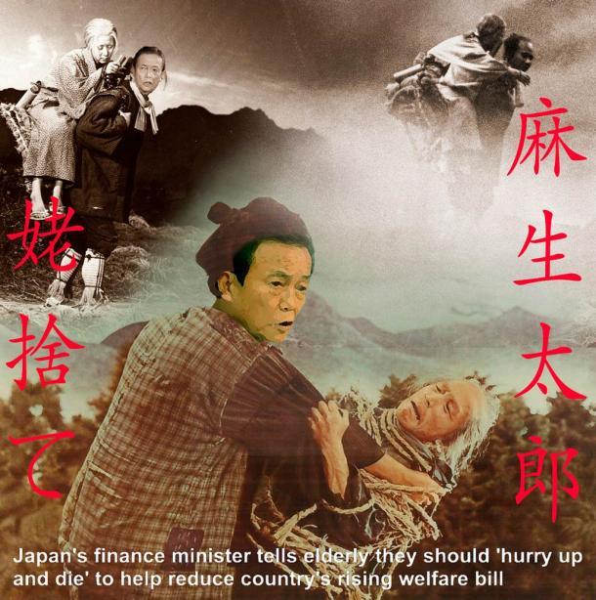

""I see people aged 67 or 68 at class reunions who dodder around and are constantly going to the doctor," he said at a meeting of economists. "Why should I have to pay for people who just eat and drink and make no effort? I walk every day and do other things, but I'm paying more in taxes."

He had already angered the country's doctors by telling them they lacked common sense, made a joke about Alzheimer's patients, and pronounced "penniless young men" unfit for marriage.

In 2001, he said he wanted Japan to become the kind of successful country in which "the richest Jews would want to live".

He once likened an opposition party to the Nazis, praised Japan's colonial rule in Taiwan and, as foreign minister, told US diplomats they would never be trusted in Middle East peace negotiations because they have "blue eyes and blond hair".

While figures released on Monday showed a record 2.14 million Japanese were receiving welfare in October 2012, Aso has led a life of privilege few of his compatriots could hope to match.

He is the grandson of Shigeru Yoshida, an influential postwar prime minister, and is married to the daughter of another former premier.

While campaigning for the premiership in 2008, Aso refused to acknowledge the use of hundreds of allied prisoners of war by his family's coal mining business during the second world war. He served as president of the firm's successor, Aso Cement, from 1973-79.."

