I'm just going to say it...the '60s, '70s, '80s, '90s, and even '00s had a very different standard for safety. So many of the things kids did back then would NEVER fly with parents today!
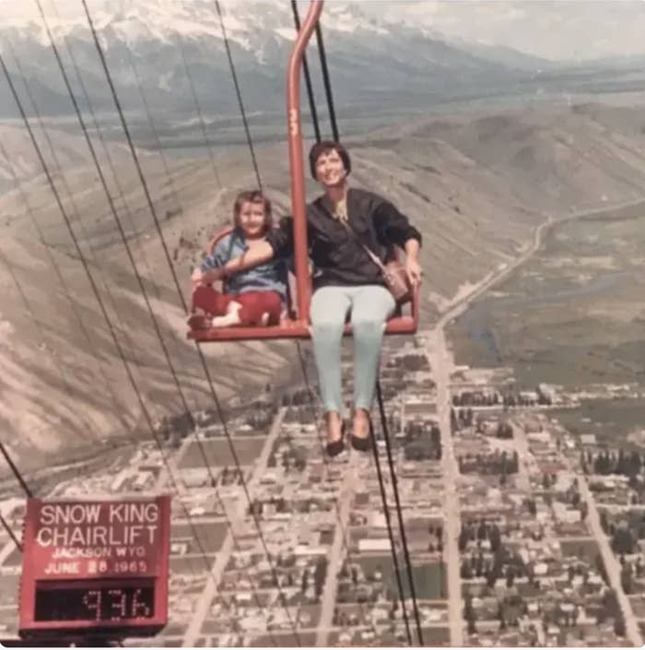

1. "Road sledding. We'd tie a rope from the bumper of a car to a sled and drag people down the road on the sled. Speeds could reach about 45 mph, and it was on the person on the sled to stop it if the car had to stop. There were quite a few times the sled rider ended up eating the bumper of the car."

—anonymous

2. "My buddy and I rode down a steep road together on a bicycle. The speedometer hit 70 mph. We were wearing shorts and T-shirts, no helmets or protective equipment. If we had a blowout or I lost control, we'd be dead."
—greghead135

3. "Car surfing — Teen Wolf style — and train hopping to get across town instead of paying for the bus. EXTREMELY DANGEROUS!!! I am sooo lucky I didn't lose a limb or die in the process."

4. "I remember being able to go to the store and purchase cigarettes for my parents. Just had to show them the permission note and pay."

—trendyhouse84

5. "I used to 'borrow' my older brother's (or Dad's) car while they were sleeping and drive all over the place. Eventually got caught (spanking of a lifetime occurred)."
—anonymous

6. "In the '90s in my hometown, we would dump gas on the rural roads around my area and light them on fire. We called them 'Go Martys,' and they were inspired by Back to the Future. We ran from the cops more than once after lighting random roads on fire. We also thought Molotov cocktails were highly entertaining and would throw them around in empty parking lots and on the road. Super dumb and not at all legal."

7. "Our grandfather would allow us to pick off squirrels and rats gnawing at his barn stores with a Ruger .22 long rifle. Pretty sure we had some off ricochets that might have gotten us in deep trouble if it was today."

—anonymous

8. "In the winter when the roads iced up, we had fun doing what we called 'hooky bobbin.' We would wait at a stop sign, and when a car would stop, we'd sneak behind the car, squat down, and grab the bumper (cars don't have bumpers anymore). Of course, when the car leaves, so do you, and that was the concept, to hang long enough to get a good slide, then let go. We had no idea how fast the car was going to go — 5 mph or 30 — but it did not matter... We were skating down the road. Everything was good unless you hung on too long and hit a spot in the road where the ice had melted."
—anonymous

9. "As a 12-year-old kid in the early '80s, we used to get old truck tires, sit in them, and then get pushed down the highway."

10. "Fireworks! Our state had them for sale twice a year — for the 4th and New Year's Eve — and these were the real deal, not the wimpy stuff they sell now. We kept going to the same place and spending $$$, so the owner let us buy some of his 'secret stash,' that is M-80s. We were careful, but I'm lucky to have all my fingers and both eyes. My hearing...uh, not so much!"

—modernshield99

11. "A group of us got kicked out of the local summer carnival for swallowing, and then regurgitating, live goldfish. (Three out of the five fish were still alive.)"
—superwittyusername

12. "We used to jump off a bridge into a stream. Not a river, but a stream...only about 50 feet across. The deepest part was only 20 feet deep. We did this every weekend, all summer long."

13. "We threw aerosol containers and lighters into the annual homecoming bonfire."

—superwittyusername

14. "Building a hangout inside trees and bushes next to railroad tracks and putting pennies on the track. Not only were we right next to the trains themselves, but stacking 5 to 10 pennies could have derailed it!"
—anonymous

15. "My best friend took care of her infant sister for several hours a day since she was 8 years old. She was alone with the baby, but there was an inside door that led to her cousin’s apartment (it was a converted single family home). So, in case of emergency, I guess there was that."

16. "I grew up in a town of 50,000, and we were all free-range kids. A few standouts: sledding down hills with no helmet, standing on a train trestle support as a train rumbled past, stupid competitions where the loser got shot in the ass with a slingshot, and rock climbing alone with no fall protection."

—markh63

17. "Playing in abandoned buildings and having fluorescent light bulb sword fights. We were wild back in the 1970s."
—anonymous

18. "Buying cigarettes from a vending machine at 13 years old."

19. "New Year’s Eve was something else back in the early '00s. I remember one year our parents bought a massive package of firecrackers and handed them out to me and my siblings. Then we headed out with our firecrackers and lighters. Unsupervised. In the night. On the one day of the year that people consume the most alcohol and drunk driving is at its peak. Also, this was before everyone had cellphones. They literally had no clue where we were or what we were up to. We had a blast, though."

—alicelofman

20. "When my stepmom was having my sister, she and my dad left me alone at midnight to go to the hospital. I was 11. I didn’t hear from them until 11 the next morning. I got myself to school in the morning, LOL."
—ladyhotmess

21. "I grew up on a dairy farm and was doing all sorts of adult-type work before I was 10 years old. This was in the 1960s and early 1970s. Driving tractors on the road? Did it! Operating farm equipment and trucks in the fields was definitely a highlight. I enjoyed it, but in retrospect, I question my parents' sanity."

22. "I don't know who figured it out, but the kids in my neighborhood discovered that whoever installed the playground equipment did a horrible job. One of the games we played was to have people swing on the swing sets while other kids shook them as hard as they could. The point was to stay on as long as possible or until we knocked the swing sets over."

—torbielillies

23. "Riding in the back of my mom's station wagon with no seatbelts."
—trendyhouse84

24. "Jumping bikes over ramps made of wood and bricks. I sprained my ankle doing that."

25. "That list is long: My young SAHM and her girlfriend would take several young kids to the beach, forcibly apply 'suntan lotion,' and then ignore us for the next three hours. We rode in the bed of trucks and without seatbelts in the front seat of the car. My brothers rode skateboards over makeshift ramps. We walked half a mile to and from the bus stop, no parents, when I was in elementary school. Lots of stuff I didn’t let my kids do."

—psycwench

26. "By 12, I was babysitting my 5-year-old sister when my Mom worked at night. DEFINITELY different times!"
—24eire88

27. "Lawn darts. Enough said."

